Used Bike Price Prediction
Project Report
1. Introduction: -
The purpose of this project was to analyse a dataset of used bikes and develop a machine learning model capable of predicting resale prices. In the used vehicle market, pricing often varies significantly based on technical specifications, age, and usage history. The objective was to understand which factors most strongly influence resale value and to build a data-driven pricing model.
This project covers the complete machine learning workflow, including data cleaning, feature engineering, exploratory data analysis, model building, and evaluation.

2. Data Overview: -
The dataset consisted of 7,857 records and included the following attributes:
- Model name
- Manufacturing year
- Kilometres driven
- Owner type
- Location
- Mileage
- Engine power
- Price (target variable)
Initial inspection revealed that the dataset contained real-world inconsistencies. Several numerical fields were stored as text, some features had missing values, and certain attributes required extraction from unstructured text.

3. Data Cleaning and Feature Engineering: -
Significant preprocessing was required before modelling:
- Text-based numeric values such as “35 kmpl”, “19 bhp”, and “17000 Km” were cleaned and converted into numerical format.
- Engine capacity (cc) was extracted from the model’s name using pattern matching.
- A new feature, bike_age, was created by subtracting the manufacturing year from the current year.
- Missing values in mileage, power, and engine capacity were handled using brand-wise median imputation, followed by global median fallback where necessary.
- Inconsistent brand names were standardized.
- Extreme outliers were identified, and bikes older than 40 years were removed to avoid distortion in regression performance.
- Categorical variables were encoded using one-hot encoding for model compatibility.
After cleaning and preprocessing, the final dataset contained 7,845 valid records ready for modelling.

4. Exploratory Data Analysis: -
Correlation analysis provided valuable insights into pricing behaviour:
- Engine power showed the strongest positive correlation with price.
- Engine capacity also had a significant positive relationship with resale value.
- Bike age and mileage showed negative correlations, reflecting depreciation effects.
- Kilometres driven had a weaker impact compared to engine specifications.
Feature importance analysis from the Random Forest model further confirmed that engine power is the dominant driver of resale value.

5. Model Development: -
Three regression models were implemented and compared:
Linear Regression: -
- R² ≈ 0.67
- MAE ≈ 29,000
Ridge Regression: -
- R² ≈ 0.66
- Performance similar to Linear Regression
Random Forest Regressor (Final Model): -
- R² ≈ 0.72
- MAE ≈ 19,400
The Random Forest model performed better, indicating that non-linear relationships exist between features and price.

6. Key Findings: -
- Engine power is the most influential factor affecting used bike price.
- Higher engine capacity significantly increases resale value.
- Depreciation due to age is more impactful than kilometres driven.
- Brand name plays a smaller role compared to technical specifications.
- Fuel efficiency has limited influence on resale price in this dataset.

7. Conclusion: -
This project successfully built an end-to-end machine learning solution for predicting used bike prices. The final Random Forest model achieved an R² score of approximately 0.72, demonstrating strong predictive capability.
The analysis highlights that performance-related features dominate resale valuation, while depreciation factors contribute moderately.
The model can serve as a baseline solution for automated pricing systems in used vehicle marketplaces and can be further enhanced with hyperparameter tuning and advanced modelling techniques.

8. Visualisation: -
1. Correlation Heatmap: -
- Shows relationships between numeric features
- Justifies why power and cc are important
- Good visual explanation before modelling

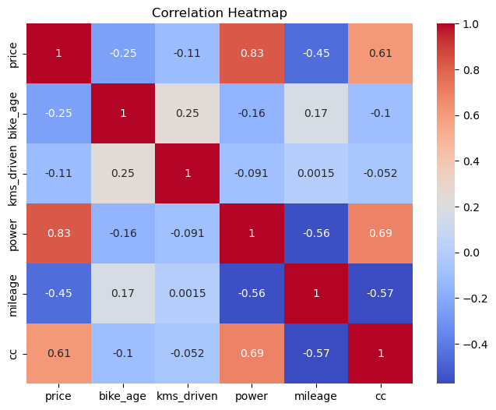

2. Price vs Bike Age (Depreciation Effect): -
- Visually demonstrates depreciation
- Easy to explain in interviews

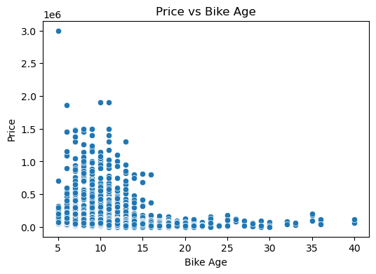

3. Actual vs Predicted (Model Evaluation Section): -
- Shows how close predictions are to real values
- Red diagonal line = perfect prediction
- Standard regression evaluation plot
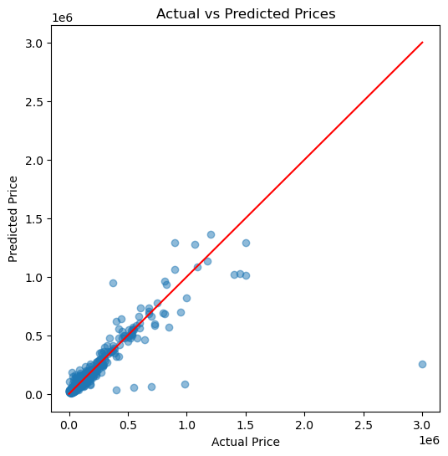

4. Feature Importance: -
- Shows which features drive price
- Confirms earlier correlation findings
- Very important for business insight discussion

